
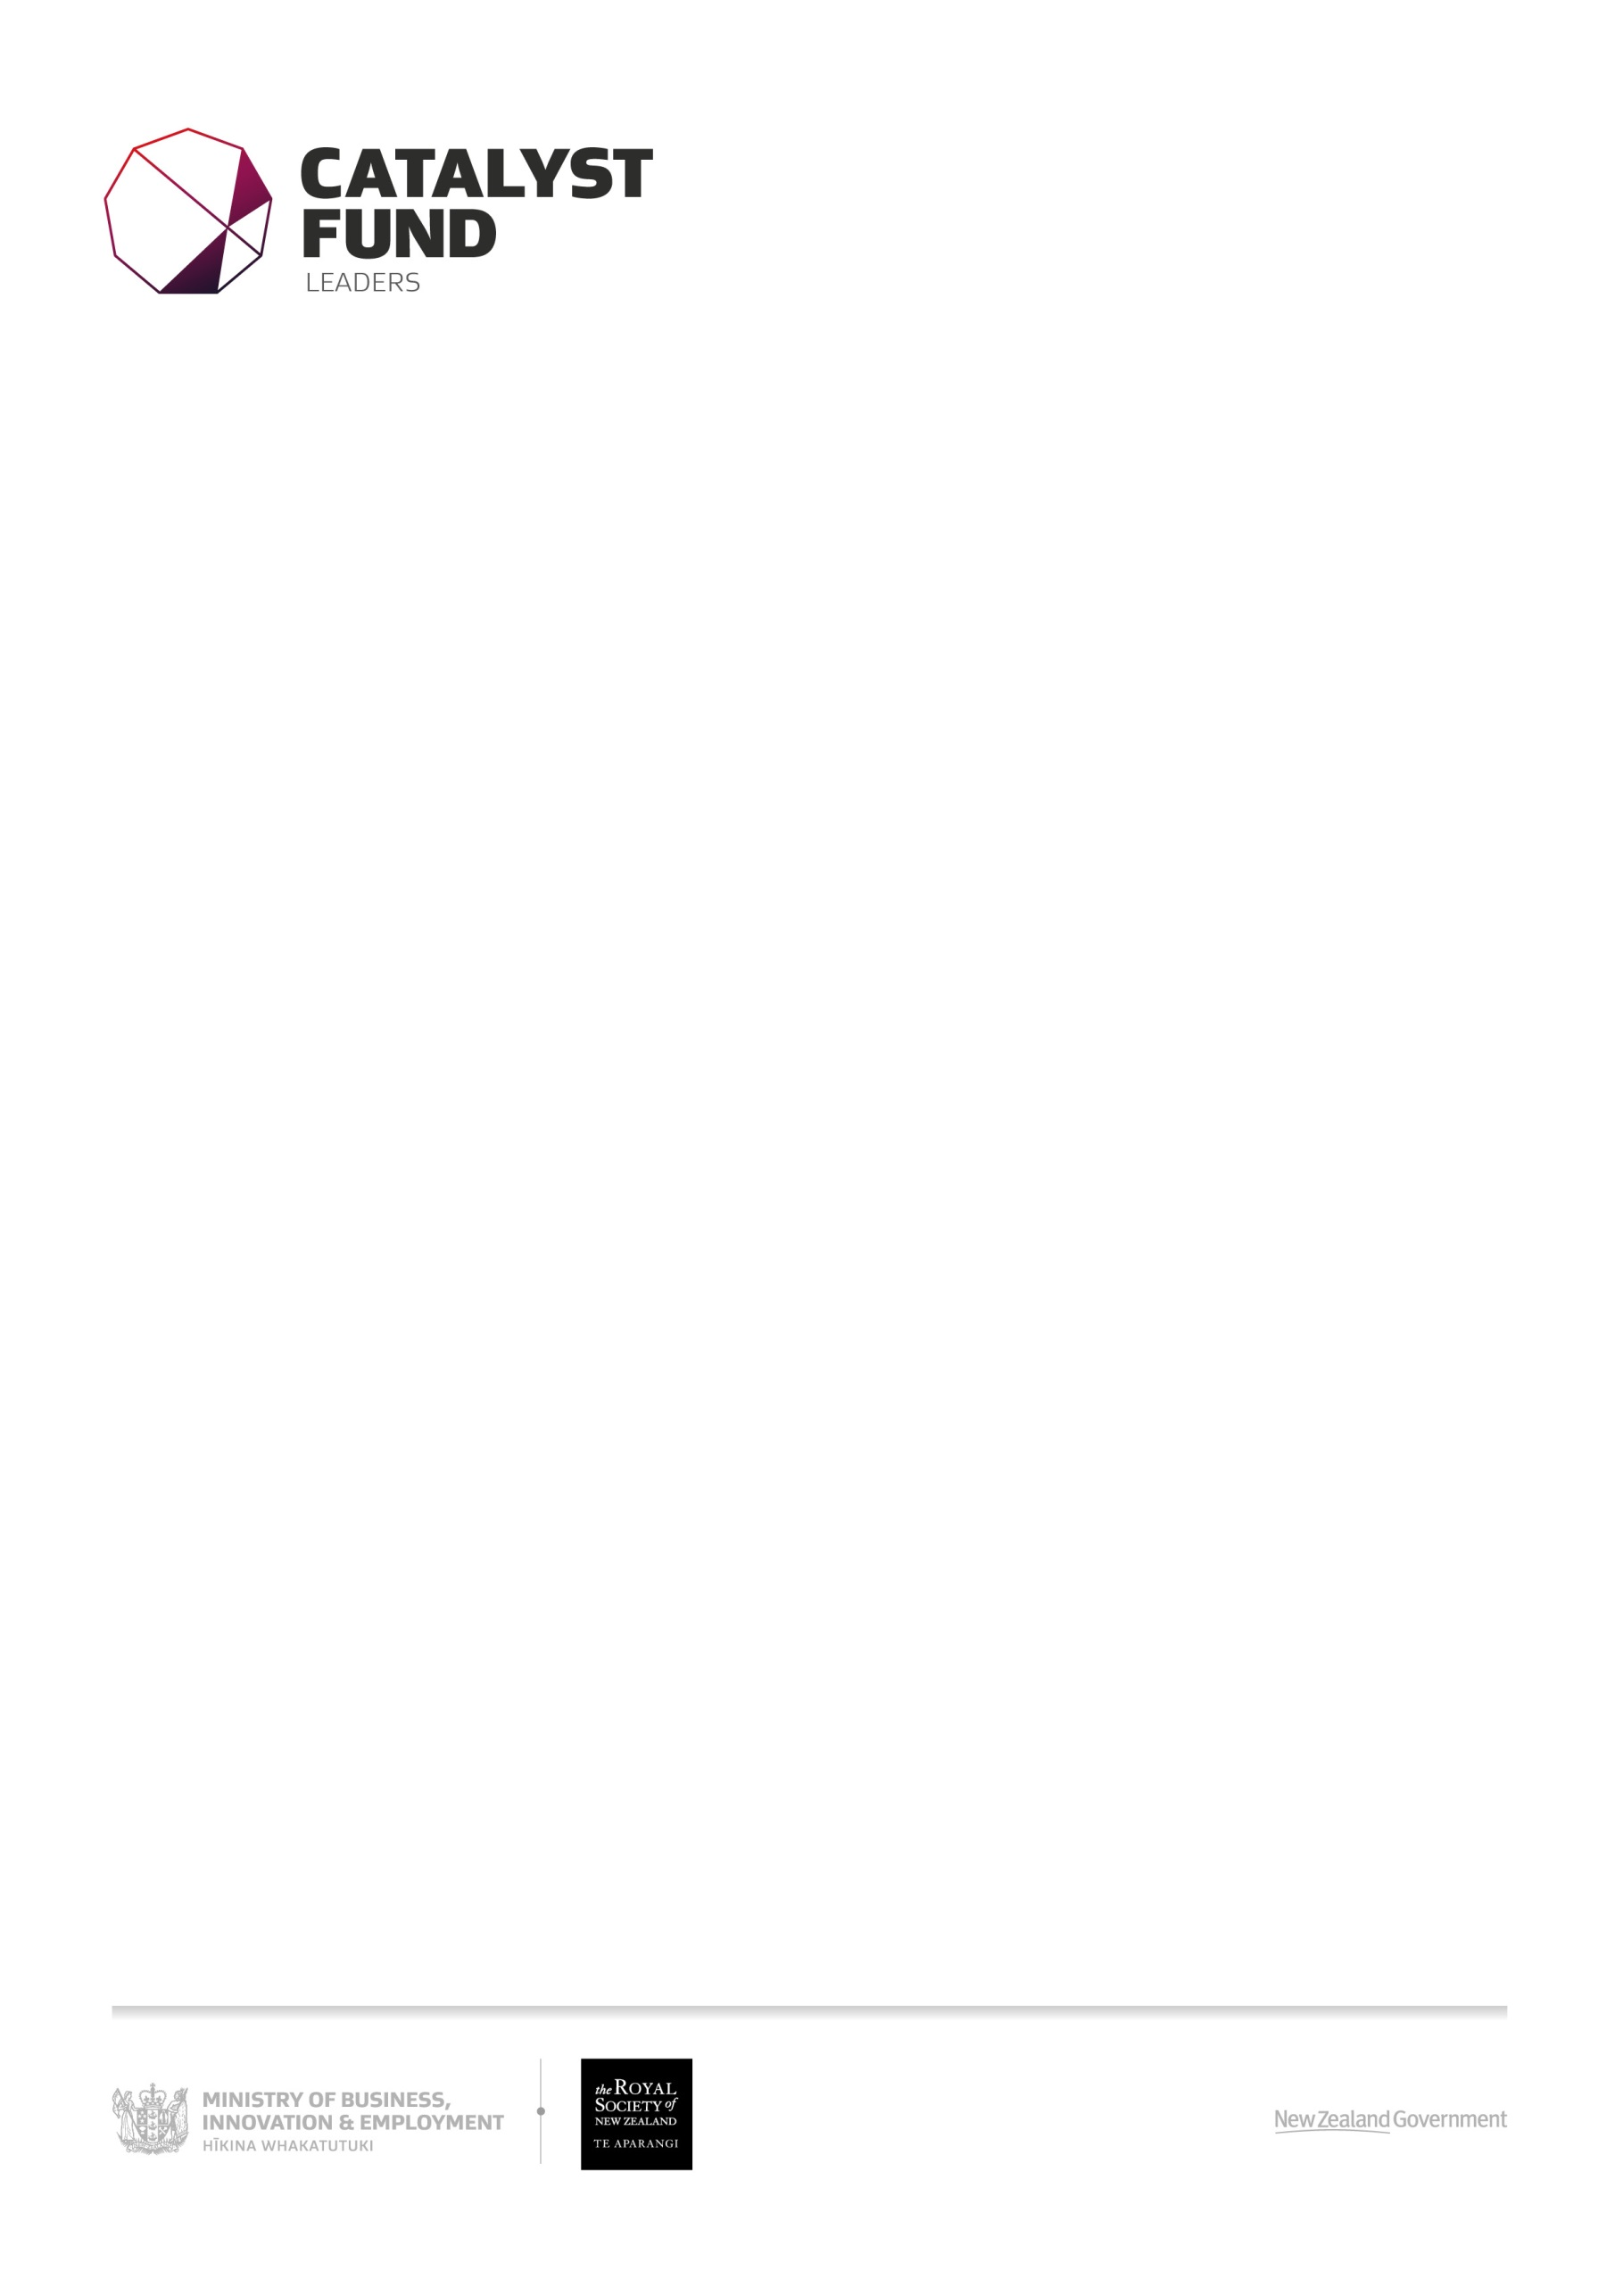

DELEGATE REPORT

16th HOPE Meeting in Japan – 2025

Your report will assist Royal Society Te Apārangi in meeting its reporting requirements
to the Ministry of Business, Innovation, and Employment. It will also help the Society in the organisation of future HOPE meetings for young researchers.

You are not limited by the space provided and you can expand any of the items below as you see fit. If you wish to include attachments and/or photos, you are welcome to do so.

SECTION A

- Name .................................................................................................................
- Email address ....................................................................................................
- Current status
Doctoral course
Postdoctoral Researcher
Other (please detail) .....................................................................................

- What was the primary motivation for your participation in the HOPE event? (Please choose one answer only)

To gain specific knowledge related research to your current research
To foster collaborative opportunities for future research projects

To establish linkages with a particular researcher at a particular lab

To acquire international research experience

To experience life and the culture of Japan
- Were the pre-departure communications with the Society useful to you in preparing to participate in the event?

Useful

Not useful
If you chose 'not useful' please explain further.

...........................................................................................................................

- How do you evaluate the overall HOPE event?

Excellent, attendance was very worthwhile

Good, attendance was worthwhile

Satisfactory, attendance was of inconclusive value

Unsatisfactory, not worthwhile at all

- Having been exposed to international research and life in Japan, what do you think the possibility is of your conducting future research in Japan or with peers from around the regions you met during this meeting?

Would like to create opportunities

If a favourable opportunity arises

Not interested

SECTION B

- Please provide your comments in approximately 3 pages, including but not limited to, the following discussion points:

  - Ways in which the HOPE meeting enhanced your research experience and promoted collaborative opportunities with international research peers? Please indicate if (and how) your visit to Japan achieved these outcomes. Were there other immediate benefits of the visit to your personal research work, such as papers expected to be published, presentations developed, networks established etc?

  - Way in which attendance to the event has supported your career aspirations?

  - Aspects of the program were the most interesting and valuable to you?

  - Any suggestions for improvement of the event and the facilitation of your attendance?

  - Advice you might give to future candidates?

  - Any other feedback and general comments you might have.

  - Public Release
Please de-select the checkbox below, if the report is not available for public release. If the report is not available for public release, please explain why.
☒ I agree to this report being available for public release.

Royal Society Te Apārangi, on behalf of the Ministry for Business, Innovation and Employment, thanks you for your reflections and feedback.

